Ideation Phase
Brainstorm & Idea Prioritization Template
Date | 3 October 2026
Team ID | SWTID-2026-9505
Project Name | Implement Client Script & UI Policy (Incident) - ServiceNow
Maximum Marks | 4 Marks
Brainstorm & Idea Prioritization Template:
Brainstorming provides a free and open environment that encourages everyone within a team to participate in the creative thinking process that leads to problem solving. Prioritizing volume over value, out-of-the-box ideas are welcome and built upon, and all participants are encouraged to collaborate, helping each other develop a rich amount of creative solutions.
Use this template in your own brainstorming sessions so your team can unleash their imagination and start shaping concepts even if you're not sitting in the same room.
Reference: https://www.mural.co/templates/brainstorm-and-idea-prioritization
Step-1: Team Gathering, Collaboration and Select the Problem Statement
Brainstorm & idea prioritization  Used to brainstorm ways to enforce dynamic field behaviour and data integrity on ServiceNow Incident forms using UI Policies and Client Scripts.  10 minutes to prepare  1 hour to collaborate  2-8 people recommended | Before you collaborate (10 min)  A Team gathering  Team members who worked on the Incident form project joined the session and shared the SkillWallet project milestones as pre-work.  B Set the goal  Focus on making Incident form fields respond to the Impact value, validate on save, and stay consistent in list edits.  C Learn the facilitation tools  Followed the key rules of brainstorming for a smooth session. | Define your problem statement (5 min)  PROBLEM  How might we make ServiceNow Incident forms enforce mandatory fields, auto-update related fields and block incorrect submissions, so that users enter clean and consistent data with minimal effort?  Key rules of brainstorming  Stay in topic | Encourage wild ideas | Defer judgment | Listen to others | Go for volume | If possible, be visual

Step-2: Brainstorm, Idea Listing and Grouping
Brainstorm (10 minutes): Each member wrote down ideas that address the problem statement.
Member 1 | Member 2 | Member 3 | Member 4
UI Policy: make Assigned To mandatory when Impact = 1 - High | onChange script: auto-set Urgency to High when Impact is High | onSubmit script: validate before save and stop incorrect submission | onCellEdit script: control Impact and Urgency edits from the list view
Set Reverse if false so fields revert when the condition is not met | Clear, readable messages for the user on the form | Test with Impact = High, Medium and Low | Server-side Business Rule as a backup check
Show an info message when a field is changed automatically | Make unnecessary fields read-only for High impact | Test the form with different user roles | Colour-highlight High impact incidents (wild idea)

Group ideas (20 minutes): Similar ideas were clustered together and each cluster was given a sentence-like label.
Group 1: UI Policy controls  Mandatory fields for High impact, Reverse if false, read-only fields | Group 2: Client Script automation  onChange auto-sets Urgency, info messages
Group 3: Validation and testing  onSubmit save validation, list-edit control with onCellEdit, role-based and impact-level testing | Group 4: Extra ideas  Server-side Business Rule backup, colour highlighting of High impact incidents, incident quality dashboard

Step-3: Idea Prioritization
Prioritize (20 minutes): The team placed each idea on the grid by importance (positive impact) and feasibility (cost, time, effort, complexity).
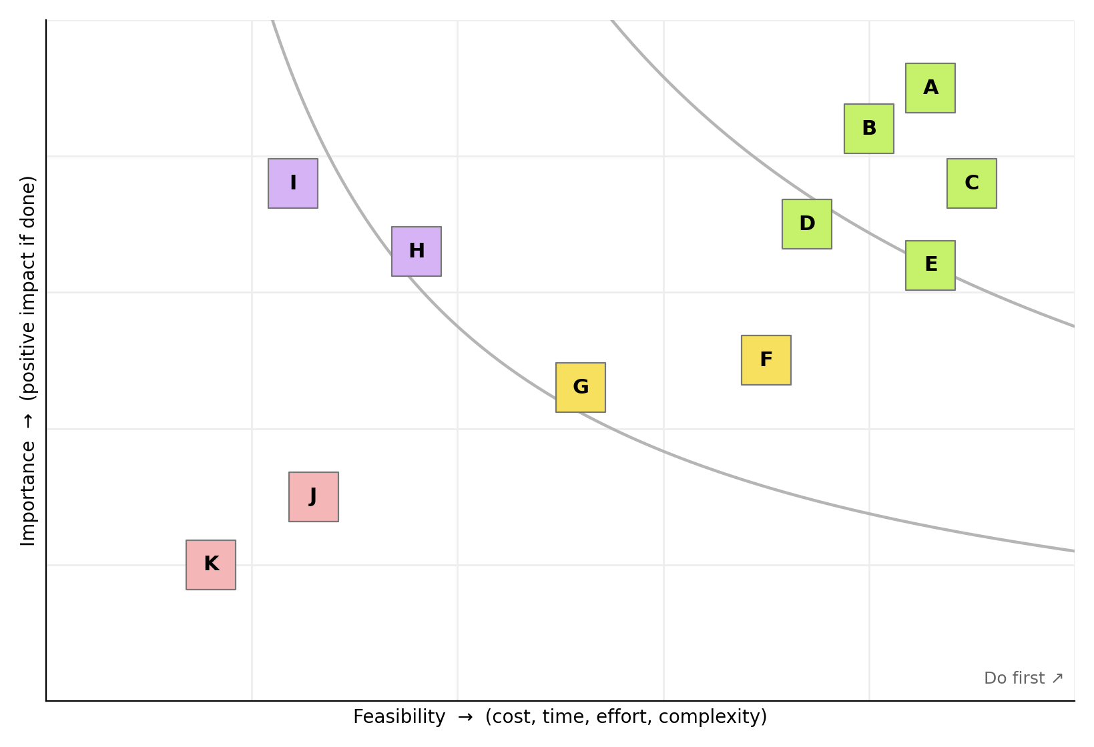
Note | Idea
A | UI Policy making Assigned To mandatory when Impact = 1 - High
B | Reverse if false on the UI Policy
C | Read-only / hidden fields for High impact
D | onChange script that sets Urgency automatically
E | Info message shown on the form
F | onSubmit validation on save
G | onCellEdit control for list view
H | Testing across Impact levels and roles
I | Server-side Business Rule backup
J | Colour highlighting of High impact incidents
K | Incident quality dashboard

Outcome: Ideas A to E (green) are the highest priority: the UI Policy, its Reverse if false setting, the read-only fields, the onChange script and the info message. F and G (yellow) come next with onSubmit and onCellEdit validation. H and I (purple) are important but harder to do now, and J and K (red) are low priority extras kept for future enhancement.

